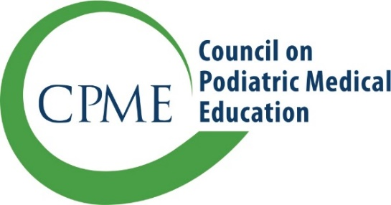
9312 Old Georgetown Road
Bethesda, Maryland 20814
cpmestaff@cpme.org
www.cpme.org

Resident Transfer Request

Programs accepting a transfer resident must submit paperwork for approval of the transfer by the chair of the Residency Review Committee. Please include this form with your request:

Receiving Institution Information
Name of Institution
Name of Resident
Transfer into which training year?
Effective Date of Transfer
Completion Date of Training
The program director attests that resident is transferring into an open position |  | Yes | No
For an off-cycle transfer, the program director attests that the transfer will not result in exceeding the number of approved positions in each year of training. |  | Yes | No
The program director has reviewed and verified all information regarding previous educational experiences and the resident’s progress toward and successful achievement of competencies and assigned activities which have been validated by an assessment. |  | Yes | No

Releasing Institution information
Name of Institution
Dates of Training | Start: [mm/dd/yy] | End: [mm/dd/yy]
Did the resident train at any other institutions? If yes, please list all previous institutions and dates of training.
The program provided all required documentation, including completed rotation assessment forms. |  |  | Yes | No
Resident passed parts I and II of the APMLE exam |  |  | Yes | No

A $250 fee must be received from the institution within 30 days of the resident’s acceptance. If payment is not made within 30 days, or if CPME is notified after more than 31 days of acceptance, the fee for the resident transfer will be $1,000.

Complete the following chart to provide information about the rotations completed and scheduled.
Rotation | Completed at/Assessed by the Releasing Institution | Scheduled during remainder of training*
Required Rotations:
Anesthesiology
Behavioral Sciences
Emergency Medicine
Family Practice
Infectious Disease
Internal Medicine
Medical Imaging
Pathology
General Surgery (competencies & assessments separate from vascular surgery)
Podiatric Medicine
Podiatric Surgery
Medical subspecialty rotations (include training in at least two of the following)
Burn Unit
Dermatology
Endocrinology
Geriatrics
Intensive/Critical Care
Neurology
Pain Management
Pediatrics
Physical Medicine and Rehabilitation
Rheumatology
Wound Care
Time spent in the Infectious Disease + time spent in the Internal Medicine and/or Family Practice rotation + time spent in the two Medical Subspecialty rotation = at least three full-time months of training: |  |  | Yes | No
If no, please provide an explanation:
Surgical subspecialty rotation includes training in at least one of the following:
Orthopedic Surgery
Plastic Surgery
Vascular Surgery
Other rotations:
Time spent in residency training will total 36 months |  |  | Yes |  | No

* Attach a schedule for the resident which includes the length, location, and date for each scheduled rotation.

