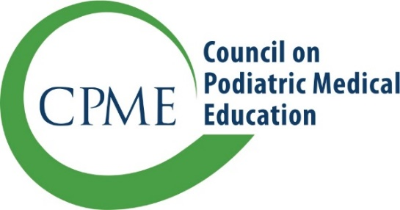
11400 Rockville Pike, Suite 220
Rockville, Maryland 20852
CPMEstaff@cpme.org
www.cpme.org

Notification of Resident Repeating First Year of Training

CPME 330, Procedures for Approval of Podiatric Medicine and Surgery Residencies, states:

Residents Repeating First Year of Training

A resident who has completed one or more years of training and wishes to restart training in a different residency program as a first-year resident is not considered a resident transfer. As such, logs and completed rotations will not transfer into meeting the requirements of the new program.

Please submit this form by email to your program liaison or to CPMEStaff@cpme.org as formal notification of a resident entering your program as a first-year resident who has already completed one year of training at another Institution.

- Sponsoring Institution Information
Sponsoring institution
Address 1
Address 2
City/State/Zip
Program Director

- Resident Information
Name of Resident
Previous Institution
Dates at Previous Institution
Effective Start Date at new Institution
Expected Graduation Date
(must be 36 months from start date)

By signing this form, the chief administrative officer(s) and the program director confirm the commitment of the institution(s) in providing podiatric residency training.

Chief administrative officer (or DIO) (Print name & Signature) Date

Chief administrative officer of co–sponsoring institution (if applicable) Date

Program director (Print name & Signature) Date

By signing this form, the resident acknowledges that they are not considered a transfer resident. As such, logs, completed rotations, and time spent at the previous program will not transfer into meeting the requirements of the new program.

Resident (Print name & Signature) Date

